TABLE OF CONTENTS

S.No. | Module No | Page No.
1 | Module 1 | 9

MODULE 1: Design Patterns and Principles
Introduction:
Design Patterns and Principles help developers write code that is clean, reusable, maintainable, and easy to understand.
This module covers:
- SOLID Principles – Rules for writing better object-oriented code.
- Design Patterns – Common solutions to frequently occurring software design problems.

SOLID Principles:
SOLID is a set of five design principles introduced by Robert C. Martin (Uncle Bob).
1. Single Responsibility Principle (SRP)
A class should have only one responsibility or job.
Example:
A class that calculates employee salary should not also generate reports or save data to the database.
Benefit:
Makes code easier to maintain.

2. Open/Closed Principle (OCP)
Software should be open for extension but closed for modification.
Example:
New payment methods can be added without changing existing payment code.
Benefit:
Makes software easier to extend.

3. Liskov Substitution Principle (LSP)
A child class should be able to replace its parent class without causing problems.
Example:
Any subclass should behave as expected when used in place of its parent class.
Benefit:
Ensures proper use of inheritance.

4. Interface Segregation Principle (ISP)
A class should not be forced to implement methods it does not need.
Example:
Use small and specific interfaces instead of one large interface.
Benefit:
Creates cleaner and more flexible code.

5. Dependency Inversion Principle (DIP)
High-level modules should depend on abstractions (interfaces), not concrete classes.
Example:
A service should use a Database interface instead of directly using a MySQL class.
Benefit:
Reduces dependency and improves flexibility.

SOLID in Short:
- S – Single Responsibility Principle
- O – Open/Closed Principle
- L – Liskov Substitution Principle
- I – Interface Segregation Principle
- D – Dependency Inversion Principle

What is a Design Pattern?
A design pattern is a standard way of solving a common programming problem.
Use of Design Patterns?
- Improve code reusability
- Reduce code duplication
- Make code easier to understand and maintain
- Provide tested solutions to common problems
- Improve software scalability and flexibility
Types of Design Patterns:
- Creational Patterns – Deal with object creation.
  - Singleton
  - Factory Method
  - Builder
- Structural Patterns – Deal with object and class relationships.
  - Adapter
  - Decorator
  - Proxy
- Behavioral Patterns – Deal with communication between objects.
  - Observer
  - Strategy
  - Command
Participation on quiz:
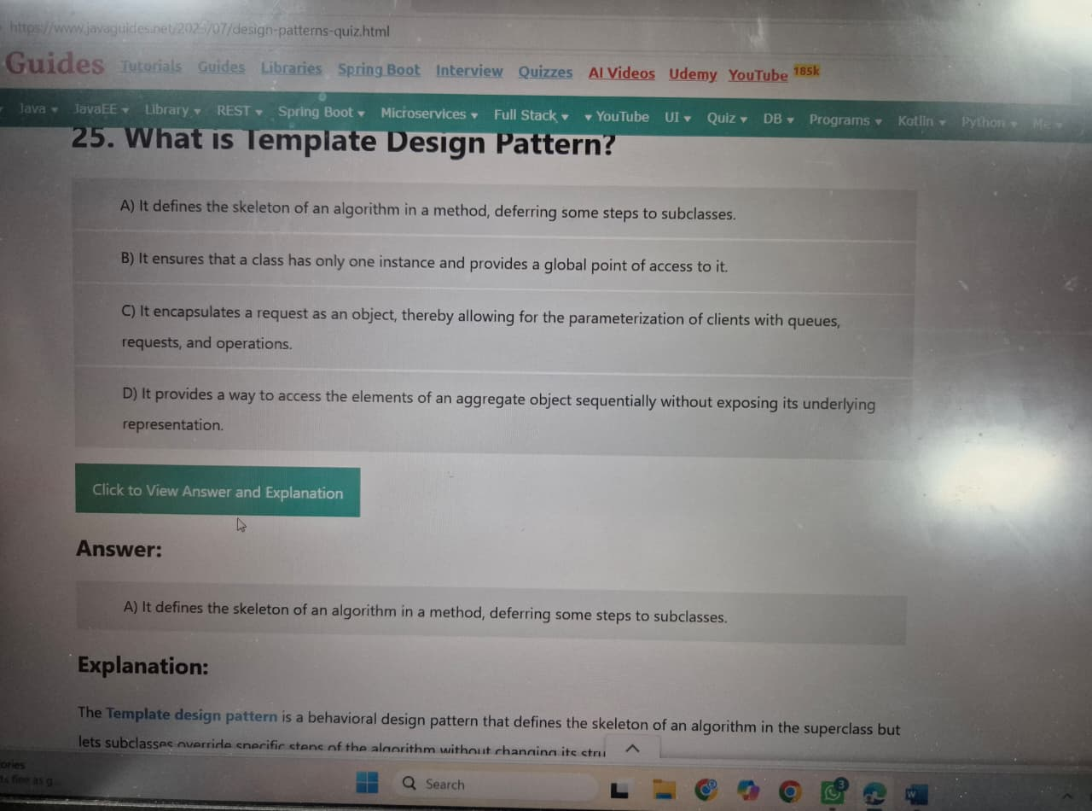

Hands on:
Exercise 1: Implementing the Singleton Pattern:
Scenario:
You need to ensure that a logging utility class in your application has only one instance throughout the application lifecycle to ensure consistent logging.
Steps:
- Create a New Java Project:
  - Create a new Java project named SingletonPatternExample.
- Define a Singleton Class:
  - Create a class named Logger that has a private static instance of itself.
  - Ensure the constructor of Logger is private.
  - Provide a public static method to get the instance of the Logger class.
- Implement the Singleton Pattern:
  - Write code to ensure that the Logger class follows the Singleton design pattern.
- Test the Singleton Implementation:
  - Create a test class to verify that only one instance of Logger is created and used across the application.

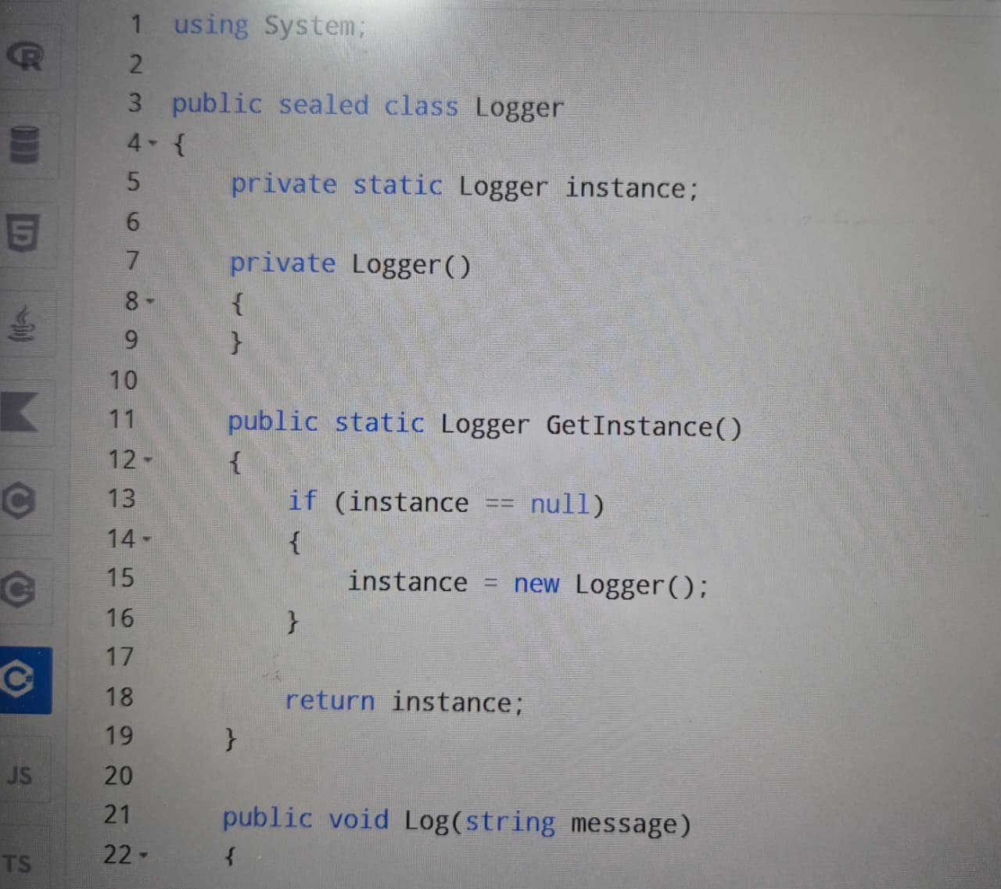

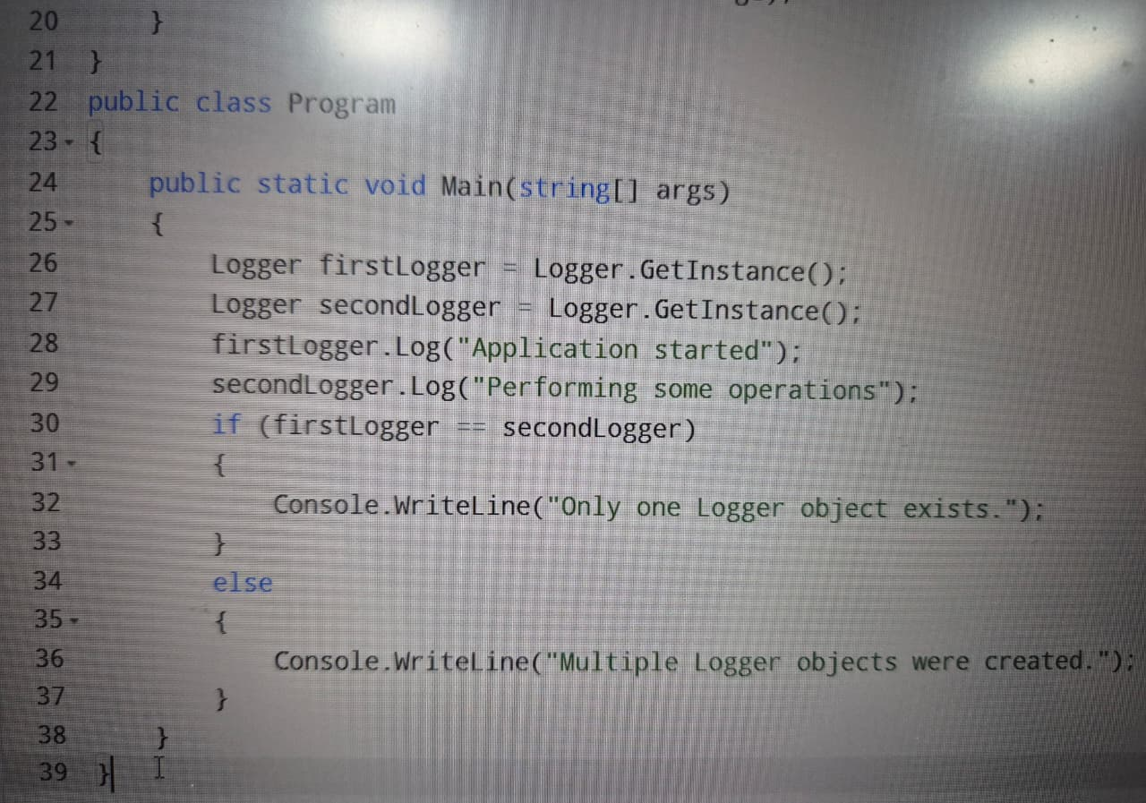

OUTPUT:


Singleton Implementation:
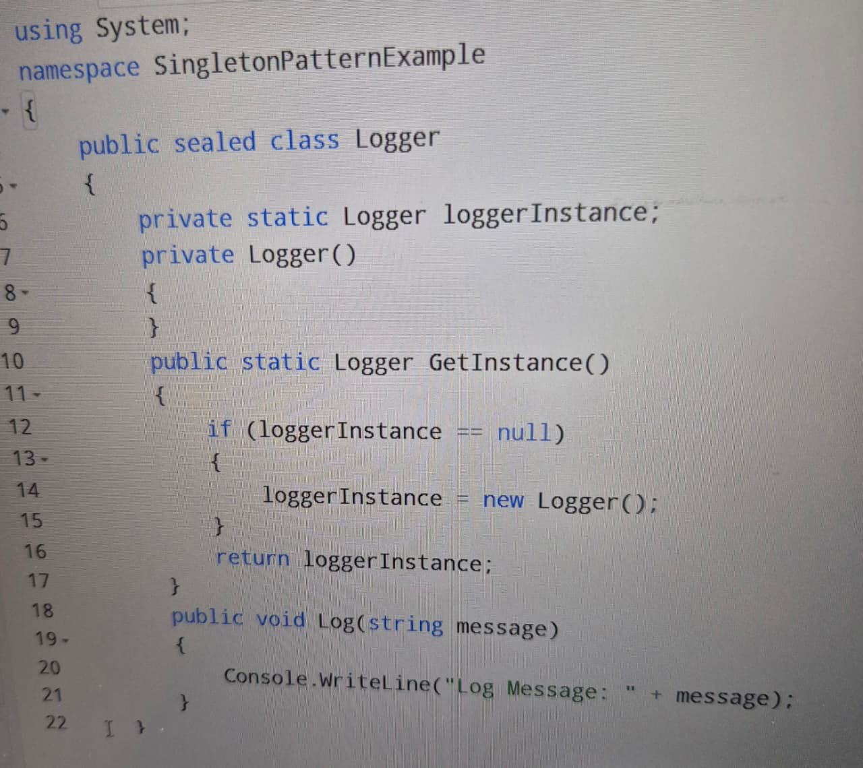

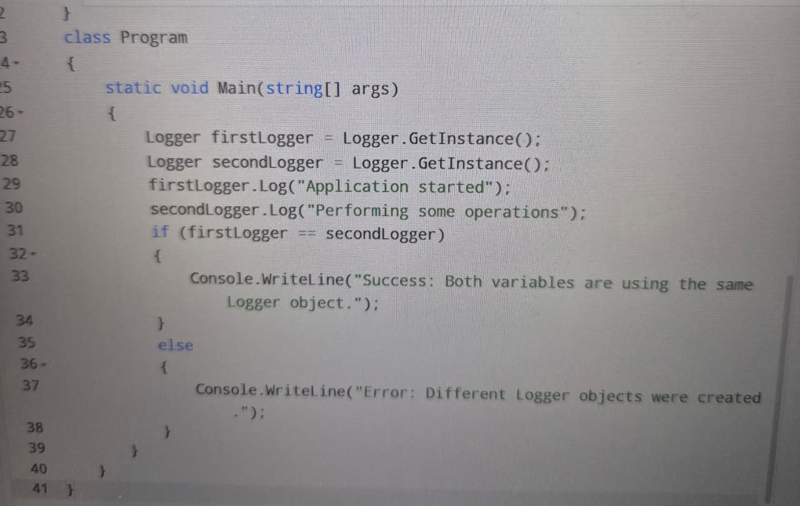

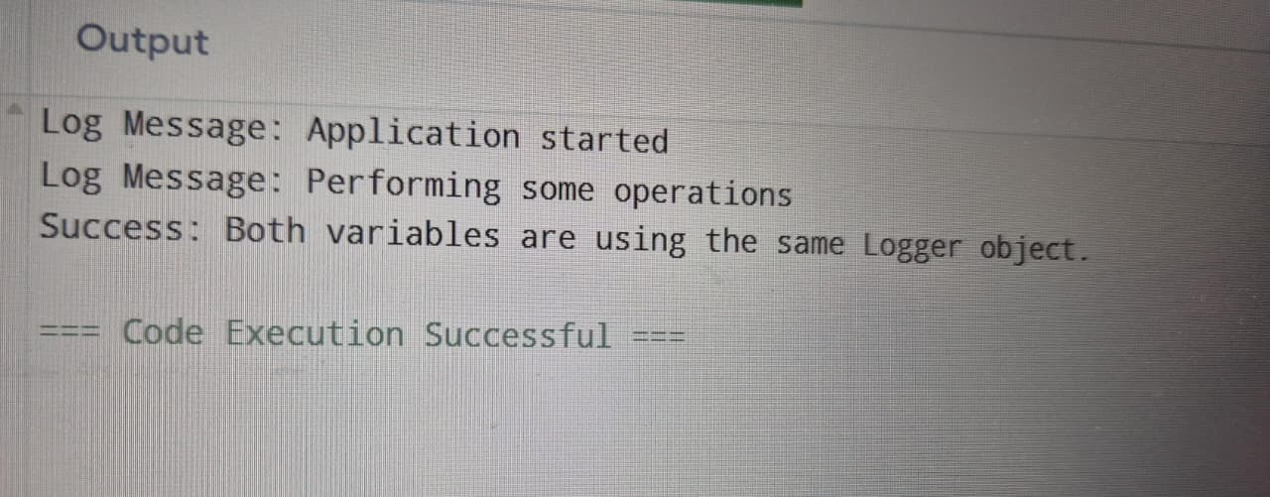

Hand`s On : ( Exercise 2: Implementing the Factory Method Pattern)
Exercise 2: Implementing the Factory Method Pattern
Scenario:
You are developing a document management system that needs to create different types of documents (e.g., Word, PDF, Excel). Use the Factory Method Pattern to achieve this.
Steps:
- Create a New Java Project:
  - Create a new Java project named FactoryMethodPatternExample.
- Define Document Classes:
  - Create interfaces or abstract classes for different document types such as WordDocument, PdfDocument, and ExcelDocument.
- Create Concrete Document Classes:
  - Implement concrete classes for each document type that implements or extends the above interfaces or abstract classes.
- Implement the Factory Method:
  - Create an abstract class DocumentFactory with a method createDocument().
  - Create concrete factory classes for each document type that extends DocumentFactory and implements the createDocument() method.
- Test the Factory Method Implementation:
  - Create a test class to demonstrate the creation of different document types using the factory method.
HANDS ON:
